November 7, 2002

Mr. David Dancause

Fullplay Media Systems, Inc.
12600 SE 38th Street Suite 150
Bellvue, WA 98006

Subject: CE Marking for “LVS2” Listening Viewing Station

Accreditations:

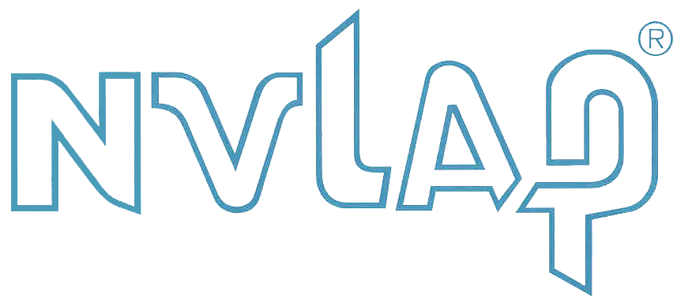

International Regulations:
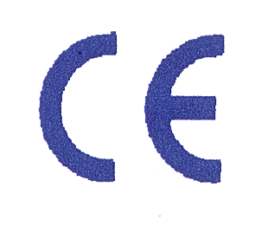
Europe

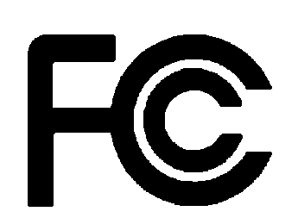
USA


Canada


Republic of China


Australia

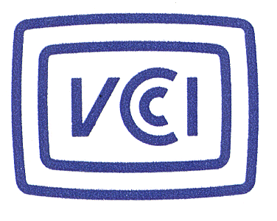
Japan

Hello David,

Below are the EMC and Safety estimates addressing the next generation LVS. If you should have further questions feel free to contact us anytime (Steve Grimes, Jack Black or myself).

This budgetary quote addresses both North American (UL/cUL, FCC) and European (CE marking) requirements.

DLS EMC Services
Electromagnetic Compatibility per:

European 89/336/EEC EMC Directive (CE)

EMISSION TESTING
Emission testing is where we measure the radio frequency energy leaving your unit. We will measure emissions from your product using EN 50081-1 calling for EN 55022 Class B limits and EN 61000-3-2, -3 Harmonic/Flicker. Additional time required will be billed at our standard rates.

EN 55022, FCC 15.107/109
Open Field
Final radiated (6 hrs.) 1,855
Final conducted
EN 61000-3-2, -3 Harmonic/Flicker report 225
EN 55022 report 285

Estimated cost for EN 55022 emissions $2,365

IMMUNITY TESTING

Immunity testing is where we determine your products performance, to energy being injected into it. The energy might be electrostatic discharge which you often experience in the winter when you touch a device or from radiated frequency radio waves generated by a walkie talkie, etc.

EN 61000-6-1 Domestic Generic immunity (replaced EN 50082-1:1997)

Using IEC 61000-4-2, -3, -4, -5, -6, -8 & -11
IEC 61000-4-2, ESD
IEC 61000-4-3, Radiated Susceptibility
IEC 61000-4-4, EFT
IEC 61000-4-5, Surges
IEC 61000-4-6, RF Cond.
IEC 61000-4-8, Magnetic Susceptibility
IEC 61000-4-11, Volt dips, interrupts

Wheeling susceptibility, 1.5 days $3,035
EN 61000-6-1 Report 550

Estimated cost for immunity $3,585

DLS Product Safety Services

Subject: Testing and Agency Liaison Services for UL Listing (U.S.),
cUL Certification (Canada) and CB Scheme through TUV Rheinland

Requirements: UL 6500:1999; CSA E60065-2000; EN 60065:1998

At DLS, it is our goal to provide you with options in the process of achieving North American (UL/cUL) and European (CE) certification. These options represent different ways accomplishing your certification goals, which are primarily UL/cUL and CE mark. You’ll see TUV Rheinland services included since the CB Scheme Report and Certificate is another means of obtaining UL and cUL approval. As always, please feel free to contact me with any questions regarding these options.

This proposal includes the estimated costs for D.L.S.C.A. to act as your technical liaison with UL and/or TUV Rheinland (as appropriate) for the services requested. For your convenience, UL and TUV cost estimates are also included (the UL estimate is our best guess based on our experience with them as a UL Certificated Agent). As mentioned above, several options will be presented in order to allow you to choose the combination of certification methods that best fits your needs.

Option 1
- Testing by DLS with UL witnessing. UL issues UL/cUL Listing, usually within 4 weeks after testing is completed.
- Compliance report (for CE marking) from DLS based on results of tests performed for UL and any additional testing related to European deviations. This report can be used along with your DLS EMC report as the basis for your Declaration of Conformity.

Option 2
- Testing by DLS with TUV Rheinland witnessing. TUV issues new CB Report and Certificate to IEC 60065, usually within 1-2 weeks after testing is completed, that includes European deviations (equivalent to EN 60065) and North American deviations (equivalent to UL 6500).
- UL/cUL Listing issued by UL on basis of acceptance of valid CB Report issued by TUV (within 2 weeks after receipt of request and copy of TUV CB Report). No witness testing by UL.

Option 3
- TUV witnesses testing at DLS and issues compliance report and Certificate of Conformity to EN 60065 (within 2 weeks after testing).
- UL witnesses testing at DLS and issues UL/cUL Listing within 4 weeks.

Certification option | Option 1 | Option 2 | Option 3
UL cost | $5000 (est.) | $2800 (est.) | $5000 (est.)
TUV cost | N/A | $3500 * | $3000 *
DLS cost | $4800 | $3000 | $3600
Total (Product Safety) | $9800 | $9300 | $11,600

* Additional requirements for the laser scanner are also applicable. The additional cost depends on whether or not the laser device has a separate certification to EN 60825 and whether the device and associated circuitry have been previously tested. This additional cost would range from $1500-2500. If the device and circuit are identical to the previously tested LVS1000, this additional cost may not apply.

DLS Conformity Assessment product safety certification services are as follows:

- Project initiation, administration/management and coordination with UL and TUV;
- Product construction review and completion of the entire test program at D.L.S. (1 day with UL and/or TUV engineers, as appropriate, witnessing), documentation of results, test sample setup / preparation for the agency visit, provide descriptive information and handle project correspondence with both agencies;
- Draft of UL product description for use in UL report; anticipated follow-up activities with UL and TUV following their visit and prior to issuance of the UL Notice of Authorization and the TUV pre-issue letter, CB Report and Certificate (as appropriate).

In summary, the cost is estimated for one device to be:

DLS EMC:
Emissions | $2365
Immunity | $3585
DLS Product Safety: | Option 1 | Option 2 | Option 3
Safety certification | $9800 | $9300 | $11,600
Total estimated certification cost | $15,750 | $15,250 | $17,550

Please feel free to contact Tom Brenner, Steve Grimes or myself with any questions you may have about this quote. And thanks again for this opportunity.

The above costs are an estimate and all final billing will be based on the time spent on your behalf. This estimate is valid for 90 days after which prices are subject to change without notice. We do expect payment in 30 days and/or before the reports leave D.L.S.

Best Regards,
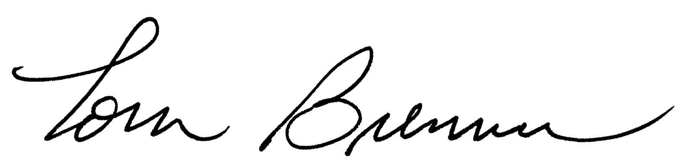
Tom Brenner
Manager – Product safety

Services:

Trouble Shooting
- Identify source of problem
- Assist with remedies to EMC problems

Consulting
- Design solutions to EMC problems
- Identify and avoid common pitfalls

Training
- Industrial on-site EMC seminars
- Univ. of Wis./DLS seminars quarterly

